Purpose:
Provide clear instructions on how to enter a PO in Dynamics with more dollars than the client agreed to schedule.

Intended Results:
Relationship Leads & Learning Coordinators understand the process for handling a PO larger than the client originally intended to schedule.

Instructions:
Clients will often send us a PO with more money than they either have scheduled or intend to use. When this happens, LCs & RLs will do the following:
- Enter the contract for only the dollar amount the client has scheduled, not the amount of the PO.
- In the contract notes, enter the amount the client sent the PO for, the amount scheduled, and the balance.
- RL will enter in an opportunity for the remaining balance and include PO number
- If/when the client schedules more classes from the PO
  - RL and LCs will work together to reduce the amount of PO opportunity by classes scheduled.
  - Add the products and dollars on the contract.
  - Add the scheduled classes to deliveries on the contract.
  - In the contract notes section, enter the date the classes were added and the new balance of the PO dollars remaining.

Here is an example of what the process looks like.

Dell sent over a PO for 150,000k, we only have ~20k of that scheduled.
If the LC were to enter the contract in Dynamics for 150k the balance of $132,00 falls into unscheduled. It’s not unscheduled work, we don’t know if the client will spend that money or not.
132k is an opportunity the RL needs to enter and track the PO number on that opportunity.

- The LC enters the contract for only the dollar amount the client has scheduled, not the amount of the PO
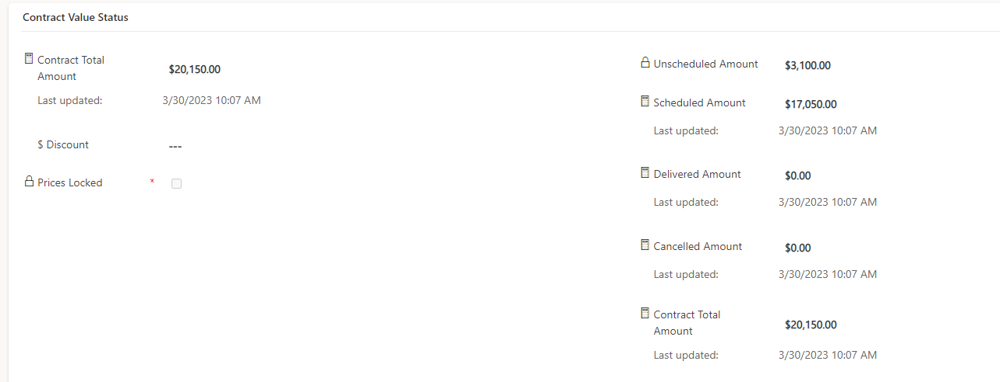

- In the contract notes, the LC enters the amount the client sent the PO for, the amount scheduled, and the balance.
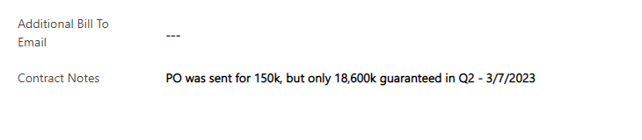
- The RL will enter an opportunity for the remaining balance AND enter the PO number.
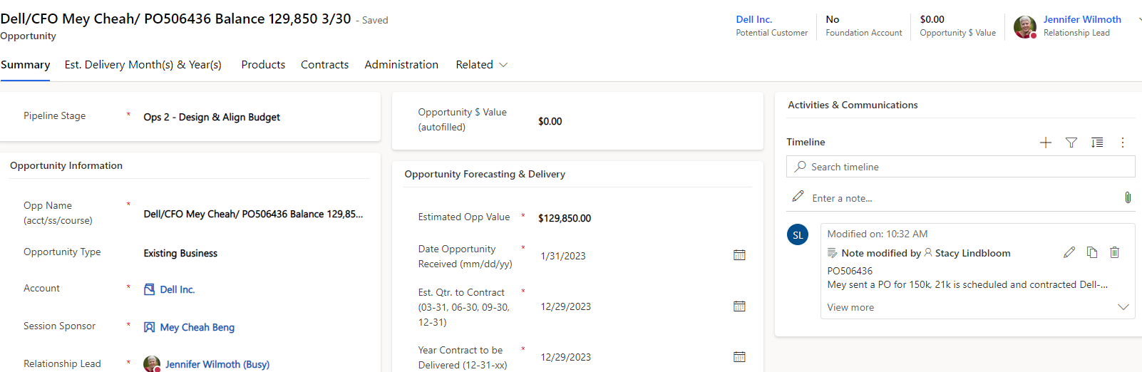

- If/when the client schedules more classes from the PO
  - RL and LCs will work together to reduce the amount of the PO opportunity by classes scheduled.
  - Add the products and dollars on the contract.
  - Add the scheduled classes to deliveries on the contract.
  - In the contract notes section, enter the date the classes were added and the new balance of the PO dollars remaining.

Responsible: Learning Coordinator Lead

Last Updated: April 13, 2023

