Confirmation of LOE & Next Steps
Stage: Pre-Class

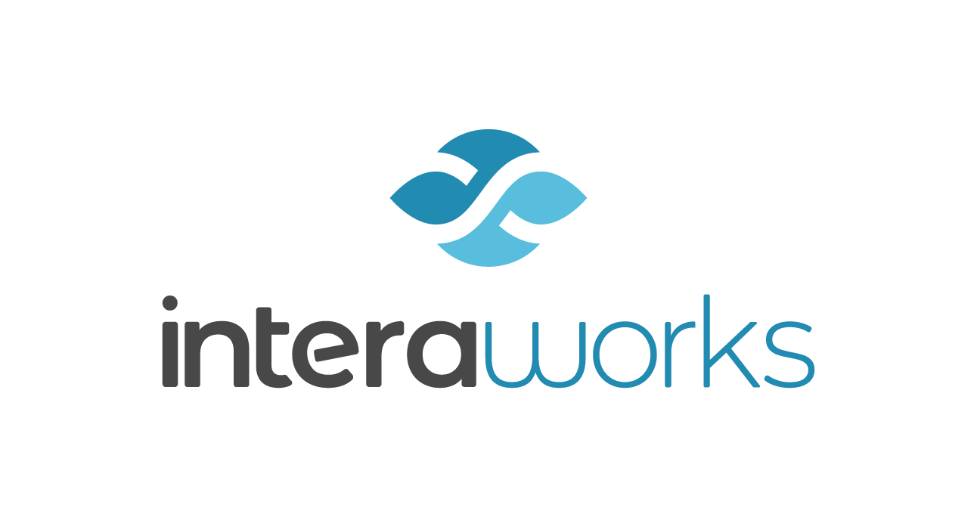

FYI: Contract received and Next Steps

Hi NAME,
We have received your completed and signed Letter of Engagement for your sessions.
The next steps in our Client Engagement Process are:
- Logistics Form
You will receive a logistics form request via DocuSign. Please complete as soon as possible (let me know if you do not receive it).
- Pre-Class Document
You will receive a pre-class document with all the access information around 2 weeks prior to the session. Once received, please distribute via email or calendar invitation to all participants.
- Pre-Class/Post-Class Call
Your relationship lead or learning coordinator will reach out to set up a pre and/or post-class calls with you and the facilitator (if appropriate).
- Course Overview & Enrollment Video
Here is a link to the course overview and a short video that explains the benefits of the program. We recommend you share these with participants to prepare them for the program. Link to Course Overview. Enrollment Video: (add link here for course and delete other)
EDGE Enrollment https://www.interaworks.com/promo-effective-…enrollment-video/
TBYL Enrollment https://www.interaworks.com/promo-take-back-…-life-enrollment/
- Roster
Please complete and return the attached roster form before the date of your session(s). The participant names and email addresses you provide will ensure learners receive post-class support for sustainability.
- Payment
Our Finance Lead, Diane Holz (Diane.Holz@interaworks.com), will reach out to set up payment for your session(s). Please feel free to contact Diane as needed with any questions regarding invoicing, PO’s, or other forms of payment.

Thanks so much and please let me know if you have any questions!

